**SP-RM – Decomposition and Software Cortland Watson**

Part I – Individual Quiz (Before Class)

Part II – Group Quiz (During Class)

1. When is one factor nested within another factor (2 pts)?
   1. It is nested when the factor only happens in one of the factor.
2. What is the estimated effect and degrees of freedom for the Within Factor of the Split Plot Design (2 pts)?
   1. Within avg -

**End of Part I**

1. Were you in class on time (2 pts)?

Yes.

1. Do decomposition of the data and an ANOVA table for the factors in the Dog Diabetes data (6 pts).

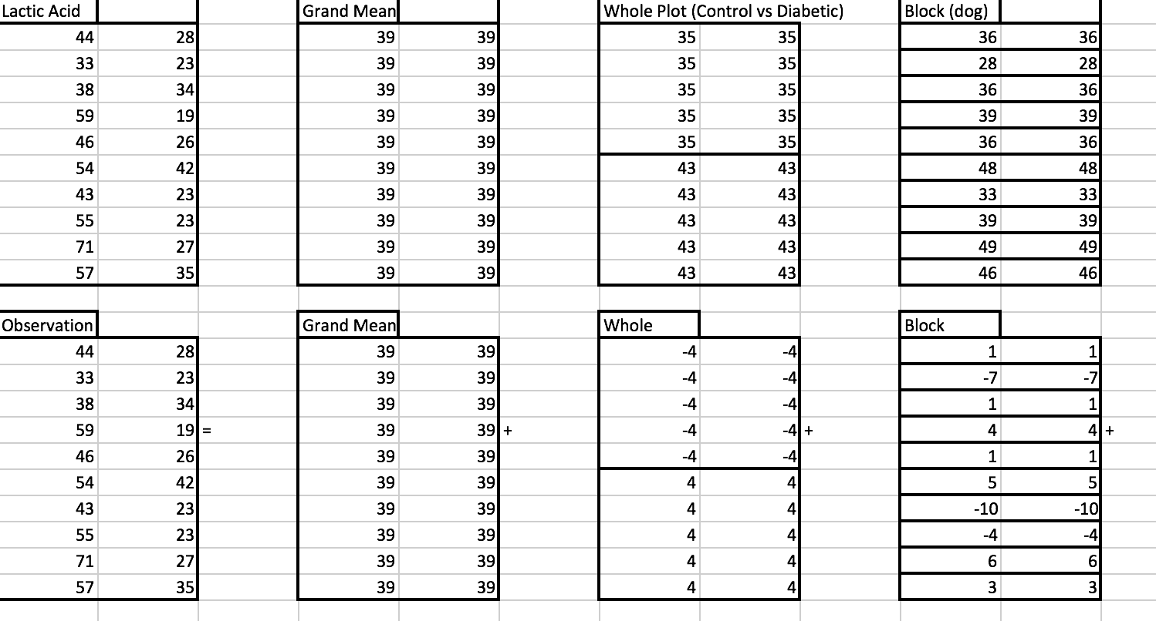

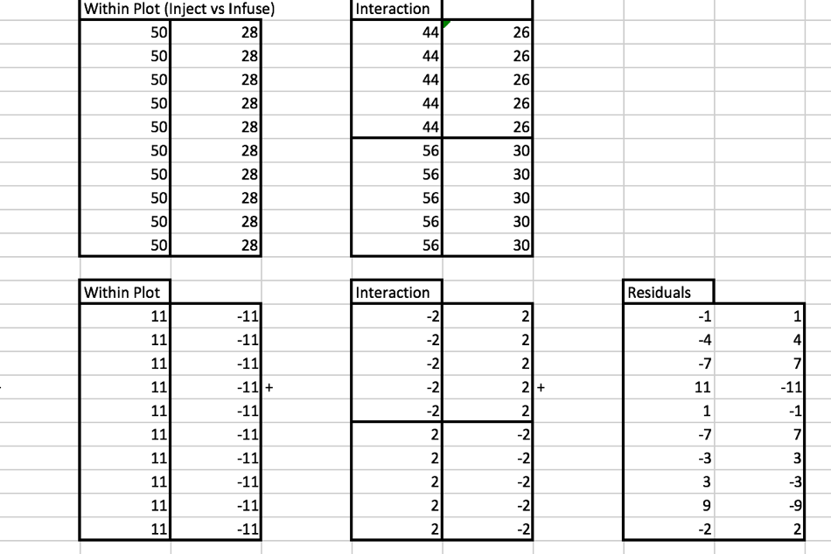

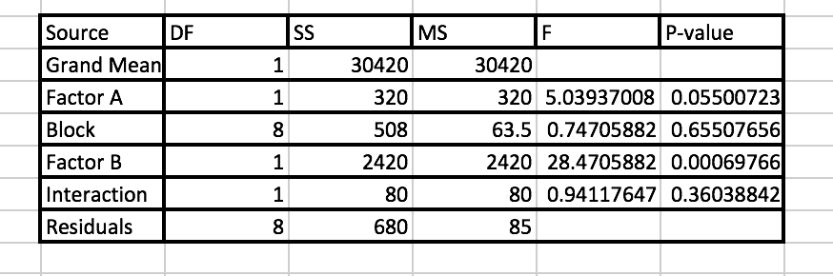

1. Get an ANOVA table for the Dog Diabetes data and evaluate the results using software. Also, check the requirements of the residuals being normally distributed as well as the variances being equal (8 pts).

